Ceres Nanotrap SOP on Opentrons Flex

(24-96 samples)
This protocol is written to process 5 µl plasma with final digestion at 47°C for 2 hours with 1 µg trypsin. Protocol name on Opentrons Flex: Ceres plasma protocol for 5ul plasma – 3 bead tubes

Variable Parameters
Name | Default | Range
Number of columns (Samples)  *in 96 well-plate format | 12 | 3-12
Incubation time | 2 hr | 1 hr, 2 hrs
Dry run | Off | On, Off

Fixed Parameters
Name | Default
Reduction and Alkylation | On
Incubation Temperature | 47°C

Materials

- Opentrons Flex 96 Filter Tip Rack 200 µL (8 is currently the maximum – all 8 slots required for 96 samples) Deck Slots A2, A3, B3, C3, A4, B4, C4, D4

- ThermoFisher 96 well plate 250 µL samples Deck Slot A1

- Empty Opentrons Tough 96 Well Plate 200 µL PCR Full Skirt (>48 samples) final peptides Deck Slot B1

- Magnetic Block Deck Slot C1

- Universal HeatShaker Adaptor (flat, rectangular) change adaptors with purple star shaped screwdriver Deck Slot D1

- Opentrons 24 Tube Rack with 2mL tubes Ceres Buffer 4; Premixed Beads; DTT; IAA; Trypsin; Deck Slot A2

- NEST 96 Deep Well plate 2 mL for multiplexing Deck Slot B2

  - Robot moved – Ceres Buffer 4 Column 1
  - Robot moved – Bead A Column 2
  - Robot moved – Bead B Column 3
  - Robot moved – Bead C Column 4
  - Robot moved – DTT Column 5
  - Robot moved – IAA Column 6
  - Robot moved – Trypsin Column 7

- NEST 12 Well Reservoir 15 mL Wash buffer; Digestion buffer; Formic Acid; Waste slots; Deck Slot D2

Notes
- PIPETTES LEFT: 1-channel 1000uL RIGHT: 8-channel 1000uL

- Samples at 5 µL volume in Deck Slot A1 (ThermoFisher 96 well plate 250 µL) in columns.

- Ceres particle A, B, and C are placed in A2, A3, A4 of Deck Slot C2 respectively
  - No bead wash required
  - Note: mixed beads will clump if delay is long

- For dry runs, a pause will initiate manual tip rack replacement

- Currently lid is not included. Evaporation is negligible for 1 hour digestions – need to test 2 hours digestion. (Not sure how to add lid for API 2.27)

- If more deck slots are required, sample plate can start on hs_mod (not sure how yet)

- Option to enable - PAUSE point to put trypsin solution.
  - Once the lysate-bead is incubating, set your timer to 25 min. In the last 5 minutes, prepare your trypsin solution/digestion buffer. Once complete, hit pause on the Robot and place tube in Slot A5, position A2.

Make sure to double check that everything is in the correct position. Refer to layout on next page.

If labware offsets are not present, perform a labware position check with the calibration probe to ensure no crashes occur.
Universal Heat shaker adaptor
C2 - Opentrons 10 Tube Rack with Falcon 4x50 mL, 6x15 mL Conical
HILIC Bead Solution (15 mL falcon tube) 12.5 µl beads/sample, provide 12.5*sample#+125 µL for 50 µg protein.
** For 25 µg protein, 6.25 µl beads is needed per sample, provide 6.25*samples#+125 µL. Add the same volume of equilibration buffer.
Protein Buffer (50 mL falcon tube) – 2% SDS, 50mM Tris pH 8 only needed if diluting samples provide required volume + 1000 µL
Digestion Buffer (15 mL falcon tube) – 20 µg trypsin in 1 mL 50mM Tris pH 8 100 µL/sample, provide 100*sample#+ (50 µL*8). If using 25 µg** protein, resuspend 20 µg trypsin in 2 mL.
DTT Stock (15 mL falcon tube) – default 110 mM 5 µL/sample, provide 5*sample#+450 µL
IAA stock (15 mL falcon tube) – default 360 mM 5 µL/sample, provide 5*sample#+450 µL

D2 – NEST 12 well reservoir 15 ml
Equilibration Buffer – 100mM Ammonium acetate, pH 4.5, 15% acetonitrile 300 µL/sample, provide 300*sample#+1000 µL
Binding Buffer – 200mM ammonium acetate, pH 4.5, 30% acetonitrile 60 µL/sample, provide 60*sample#+1000 µL
Wash Buffer – 95% acetonitrile (5% water) 300 µL/sample, provide 300*sample#+1000 µL 300*sample#+1000 µL

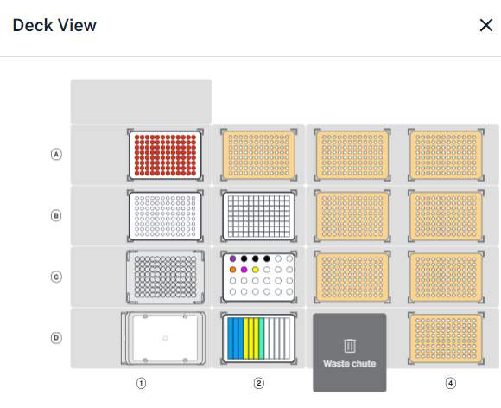
A3
A4
A1
B1
B2
B3
A2
P200 filter tips
Thermofisher 96 well plate 250 ul
Samples
NEST 96 Deep well plate 2 ml
New 96 well plate, 200 ul PCR Full skirt
Magnetic Block
Heater-Shaker
A4-6
A7
A1-3
Slot A2 – Opentrons 24 Tube Rack with 24 x 2 mL
Ceres Buffer 4 (2 mL tube) 15 µl buffer/sample provide 15*8*Column# + 80 µl
- A2 – Position A1
Ceres Bead A (2 mL tube) 7 µl bead mix/sample 7*8*Column# Bead A + 50 µl
Ceres Bead B (2 mL tube) 7 µl bead mix/sample 7*8*Column# Bead B + 50 µl
Ceres Bead C (2 mL tube) 7 µl bead mix/sample 7*8*Column# Bead C + 50 µl
- A2 – Positions A2, A3, A4
DTT (2 mL tube) – 500 mM 5 µL/sample, provide 5*8*Column# + 100 µL
- A2 – Position B1
IAA (2 mL tube) – 375 mM 5 µL/sample, provide 5*8*Column# + 100 µL
- A2 – Position B2
Trypsin (2 mL tube) – 200 µg/mL 5 µL/sample, provide 5*8*Column# + 80 µL
- Resuspend 20 µg Trypsin stock in 100 µL
- A2 – Position B3
Slot D2 – NEST 12 well reservoir 15 ml
Wash Buffer – water 200 µL/sample (2 washes), provide 200*8*Column#+1000 µL
- D2- Column 1 (and column 2 if samples > 45; increase dead volume)
Digest Buffer – 50mM Ammonium bicarbonate in water 200 µL/sample, provide 200*8*Column#+1000 µL
- D2- Column 4 (and column 5 if samples > 45; increase dead volume)
Quench Solution – 5% Formic acid in water 10 µL/sample, provide 10*8*Column#+2500 µL
- D2- Column 7 (and column 5 if samples > 45; increase dead volume)

